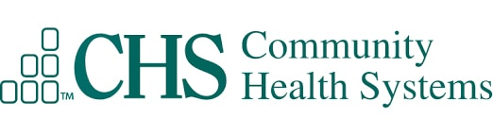

Architecture Intake

Assessment

Table of Contents
Table of Contents 1
Architecture Assessment Questionnaire 2
Business Case for Software 2
Scale 2
Licensing: 2
Application: 3
Servers: 3
Endpoint Software: 4
Network: 4
Management / Administration: 5
Database: 5
Interface: 6

Architecture Assessment Questionnaire

Business Case for Software
1. Please explain the use case(s) for application?

Leveraging the current Vigilance system you have deployed enterprise wide on-prem. LaborWatch is an extension module that allows persistent conditions to be sent to the OB chain of command per facility. Currently the messages are sent via SMS and there is a current project to migrate these to TigerConnect.

2. Is this a cost saving or generating solution?

Most likely the latter.

Scale
1. Is there a cloud-based offering? If so, what service models (IaaS, PaaS, SaaS) and deployment models (Private or Public) are supported?

The base system is hosted on-prem (PeriWatch Vigilance). The module in question (LaborWatch) sends notifications to a PeriGen private instance of Atlassian Jira (cloud) which then sends the text-based notifications to the appropriate clinician’s phones via SMS. There is no ePHI in the messages. This model will be migrated to send the same to TigerConnect within several months.

2. Is this a managed solution?

This is fully supported by PeriGen.

3. Can you provide functional and technical diagrams?

Below is the current architecture diagram:
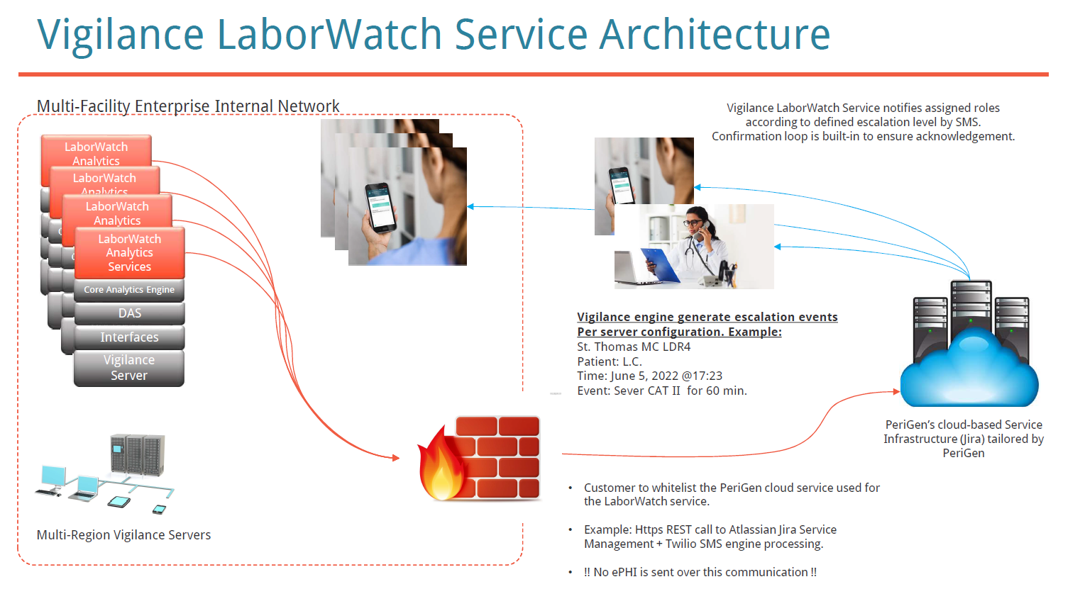

4. Do you include any 3rd party software as part of your product?

None as part of the products installed on-prem. As mentioned above, the routing of messages uses the PeriGen private cloud instance of Atlassian Jira.

5. Does your product support High Availability Platforms?

No change to the current deployment model (using CHS clustered SQL and VMware HA)

6. How does your product scale for future growth and availability?

The system is fully hosted on-prem (CHS). Each region has its own Vigilance server. There are currently 4 regional servers at CHS. Each server has a general capacity for ~400 simultaneous monitored patients across multiple facilities. If/when capacity is exceeded, new servers have to be instantiated. To date, birth rates have been relatively steady and no expansion was needed.

Licensing:
1. What is the solution licensing model?

The system is already licenses. The licensing model is per birth.

2. What client licensing is required for each end user or desktop?

None. Site license.

3. Are there any third-party licenses required?

No. CHS already provides licenses for MS SQL. Everything else is provided by PeriGen and integrated to system cost.

Application:
1. Is there usage of proprietary technologies?

The software used include machine learning algorithms that are proprietary. Other than that, the technical infrastructure is all based on Microsoft technology stack: Windows server OS, MS SQL, IIS, .Net Core.

2. Are there any open source used in your solution?

Some libraries are used for the software development process but none are deployed with the production system + all such libraries are completely public domain/royalty free/license free libraries.

3. Does the product integrate with collaboration systems such as email and content management systems?

On SMS today as part of the LaborWatch extension module.

4. Does the product require additional software to support web presentation?

None beyond a modern browser (Google Chrome or MS Edge Chromium)

5. What is your development and release cycle?

There are typically 1-2 maintenance releases a year. Hot-fixed are released depending on severity (bugs/security)

6. What is your test environment strategy?

Each customer (including CHS) has a TEST system where new software is deployed for customer approval prior to scheduling upgrades to PROD.

Servers:
1. What are all the supported Operating System (OS) platforms and their versions across the solution?

Windows 2016/2019 Server Pro.

2. Describe the OS platforms and their configurations at all tiers of the solution.

Windows 2016/2019 Server Pro. For servers and Windows 10 for client.
3. Has the solution been tested and/or certified with new OS platforms or emerging OS platforms that are in planned release within the year?

Testing for Windows 11 and Server 2022 is planned for the next release cycle.

4. If there are multiple OS platforms available (that compete), provide the recommended OS platform(s) with pros and cons contrasted by your solution set.

No.

5. Are there recommended platform recommendations based on the size of the organization and/or the size of the solution? If so describe the recommendations.

None. System is already operational.

6. Does your product support server virtualization?

Yes.

7. Any special hardware peripherals required?

No.

8. What server roles are required in your solution?

Servers are used as application servers. All data is stored in MS SQL which CHS manages as part of the enterprise cluster.

Servers: <Seems to be a repeat of the previous section>
1. What are all the supported Operating System (OS) platforms and their versions across the solution?

2. Describe the OS platforms and their configurations at all tiers of the solution.

3. Has the solution been tested and/or certified with new OS platforms or emerging OS platforms that are in planned release within the year?

4. If there are multiple OS platforms available (that compete), provide the recommended OS platform(s) with pros and cons contrasted by your solution set.

5. Are there recommended platform recommendations based on the size of the organization and/or the size of the solution? If so describe the recommendations.

6. Does your product support server virtualization?

7. Any special hardware peripherals required?

8. What server roles are required in your solution?

Endpoint Software:
1. What client models are supported:
a. Mobile – What platforms, application type (app vs. web based) and the limitations
b. Browser – What browsers are supported and what standards are used (ex: HTML 5)
This is the current model.
c. Thick Client – What OS platforms are supported?

2. Does your product require any browser plug-ins or special software?

No

3. Is your product compatible with Windows 64-bit client systems?

Yes

4. Do you support application Virtualization?

The main application is delivered via the browser. There is a client application called the Vigilance Notification Agent (VNA) which is a thick app to provide workstation-based notification (pop-ups). The app is minimized to the tray and pop-up a notification when appropriate. As such, it does not support application vistualization.

5. Is your application software packaged as an .MSI or Exe?

Not applicable to the browser client which is accessed by URL. The VNA is a small directory/file set that needs to be pushed to every workstation. Following first deployment, an auto-update is available depending on permissions.

6. Does it require admin privileges to certain directories?

If VNA auto-update is required, modify rights are needed to that directory (client side). Otherwise, no.

7. What is your minimum Internet browser standard?

Google Chrome or MS Edge Chromium

8. Does your product require a specific version of Java?

No.

9. Software required to write to a network share for any reason?

No.

Network:
1. Describe communication ports and ability to move across the enterprise and outside the company firewall (if required).

For the Vigilance application, there is no requirement to use/access outside the hospital network. Any remote access is managed by CHS. The LaborWatch module sends notification messages to the PeriGen private instance of Atlassian Jira. To date, there are no restriction for that outbound traffic. That communication channel is encrypted and does not contain any ePHI.

2. What type of network connection does your system require?

Standard internal LAN

3. Is load balancing supported and implemented in the solution?

No

4. At what level is load balancing supported? (ex: application and/or at the network level)

NA

5. Does your product require access to systems outside of CHS?

No

6. Does your product support CISCO routing protocols?

Not specifically. All network communication is does over standard TCP/IP using https.

7. Does your product require wireless access?

No.

8. Does your application require multicast?

No.

9. Does your product have specific port requirements?

Yes. There are no present restriction for any of the ports used by the system.

Management / Administration:
1. Is an administrative interface included with your product?

Yes but it is mainly used by PeriGen support for any configuration changes requested by CHS clinical leadership.

2. Does your product provide tools for performance reporting?

No

3. Do you provide troubleshooting and debug tools?

No

4. Does your product require scheduled downtime for backups or maintenance?

No (updates/upgrades excluded)

5. Does the product have alert and notification capabilities?

Yes

6. Is your product identified as FDA restricted?

“Restricted” no. It is a class II medical device.

7. Does your product support operating system patching? What is your patch schedule?

Yes, it is the customer’s responsibility to maintain OS patching up to date.

Database:
1. Does your product utilize Microsoft SQL or Oracle?

MS SQL

2. Does your product provide database reporting tools?

Reports are provided on MS SSRS on an instance provided by CHS.

3. What is your concurrent user capacity?

No limit

4. Explain growth kb/mb based off transactions.

~200GB per year per regional server.

5. Does the product provide an archiving tool?

Archiving is built-into the SQL server model. Visits are off-loaded/archived to “archive DBs”.

6. Do you provide scripts for database maintenance?

Maintenance tasks and backup model are determined jointly at the onset of the project. After that, it is the customer responsibility to execute the maintenance plans/backup.

7. Do you support clustered databases / high availability groups?

Yes (already used in PROD)

Interface:
1. Does your system require any type of interface or data extract?

No

2. Does your product support HL7?

Yes. Interfaces are already used from Cerner and GE

3. Does your product support message structures other than HL7?

HL7 only

4. What type of interfaces does your product support?

HL7 ADT and Results inbound and outbound

5. Does your product maintain real-time or batch transaction processing?

The system comes built-in with an instance of Rhapsody interface engine. Messages are routed, cached and processed depending on configuration.

6. Does the interface service of your product require an active user login?

Presently no.

